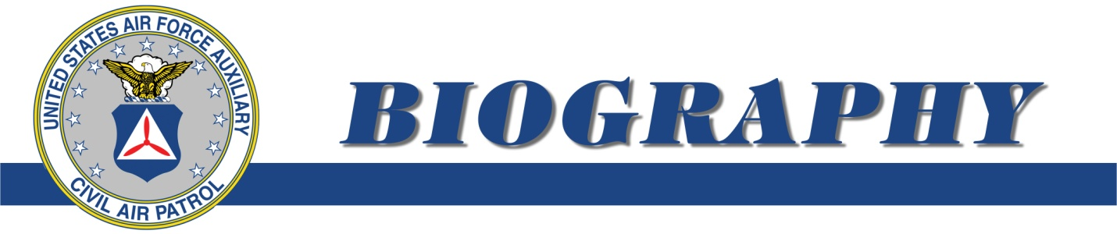
COL CHRISTOPHER J. HAYDEN
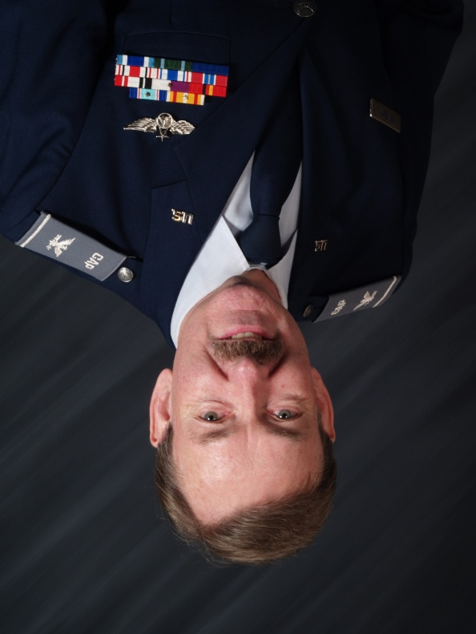
Christopher Hayden is the former Northeast Region Commander serving from August 2009 to August 2013. Civil Air Patrol is a federally chartered nonprofit corporation and is the official all-volunteer Auxiliary of the U.S. Air Force, headquartered at Maxwell Air Force Base, AL.

His primary duty during his term was leading the northeastern wings comprising Connecticut, Maine, Massachusetts, New Hampshire, New York, Pennsylvania, Rhode Island and Vermont in their fulfillment of the organization’s three congressionally chartered missions: Emergency Services, Cadet Programs and Aerospace Education, as well as CAP’s increasing role in America’s homeland security.

As a region commander, Hayden served on the National Executive Committee and the National Board.

As the Northeast Region Commander, Hayden commanded 9,000 members in 94 units. He lead CAP’s three region wide Disaster Relief participation following Super Storms Irene and Sandy, regionalized and established training procedures for the Keynote Air Defense Missions, initiated the region’s glider academies for the cadets, and established the Region Cadet Leadership School.

Col Hayden was appointed Northeast Region Commander having served as the Wing Commander for Maine where he expanded the wing’s US Navy’s ship escort missions and revitalized the wing’s relationship with the Maine National Guard, Maine Emergency Management, Maine Drug Enforcement Agency and began statewide fire patrols for the Maine Forest Service.

Hayden joined Civil Air Patrol in 1997 having moved to Maine from California to lead the launch of a new international television channel. Hayden joined the 58th Composite Squadron as the public affairs officer and soon became the squadron commander.

Hayden’s professional career spans 40 years as the owner and executive producer for two film and television production companies and eventually the Chief Executive Officer of the New York based Gavelnet Television Network. Prior to this Hayden worked in the United Kingdom for the British Broadcasting Corporation.

As a mission pilot for Civil Air Patrol, holding an instrument rating and commercial pilot certificate he has since accumulated over 1,000 of his total 2,000 flying hours.

